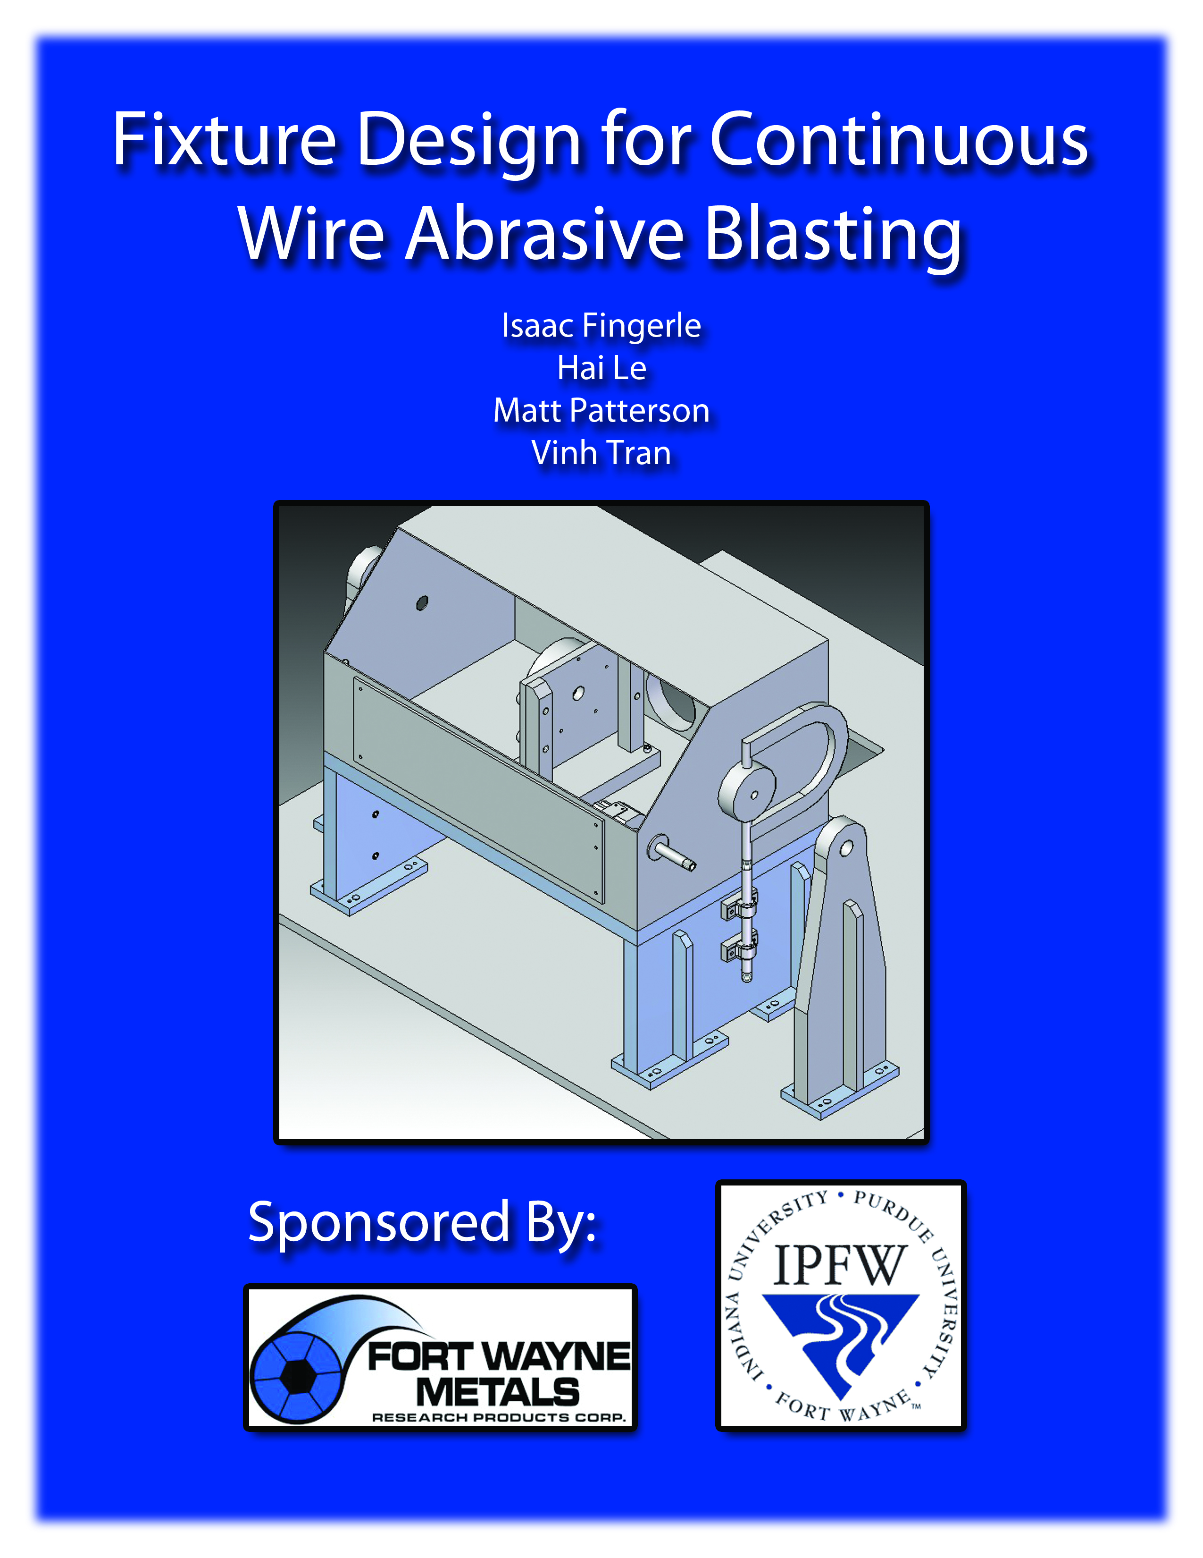

April 26, 2011
To Larry Kay, Jamie Weller, and Fort Wayne Metals staff:
This report includes prints and layouts to fabricate the necessary fixtures to replicate our design. We have included full drafts, solid models, and descriptions as to how each component is to be built and assembled. Our group wishes we could have reached the testing phase, but time wasn’t on our side. We have included the testing method we would have proposed if we made better progress.
Thank you for providing us with a project that gave us real engineering experience along with access to so many resources. If you have any questions or would like further support from our team members, don’t hesitate to contact us.

Contact Information and Project Areas
Isaac Fingerle – Primary fixture design and modeling assembly, testing theory
(260) 409-6479 | fingip01@students.ipfw.edu | fingip01@gmail.com
Vinh Tran – Research and blasting equipment comprehension, air wipe design, testing theory
(260) 804-5234 | vtran1982@yahoo.com
Matt Patterson – Workstation plugging and hole fabrication, splitter mounting
(574) 323-4390 | matthewrpatterson1@gmail.com
Hai Le – Workstation plugging and hole fabrication
(260) 579-6663 | le2_05@yahoo.com

April 26, 2011
To Dr. Barry Dupen, MET Senior Design Instructor:
We have done our best to document our work over the course of the Spring 2011 semester. We detail the process to be replaced and background information along with research conducted for potential solutions. Proposed layouts that didn’t pass Fort Wayne Metal’s satisfaction are also included.
Thank you for contacting Fort Wayne Metals allowing us to have such an excellent project and experience, and for keeping us on-task making sure we haven’t overlooked anything.

April 26, 2011
To Dr. Suzanne Rumsey, English Instructor:
The report given to you is the same version as the ones given to Fort Wayne Metals and the MET Department. The tone of our report is for FWM engineers, but somebody not in the engineering field should still be able to understand most of this document. Thank you for helping us writes professionally and gives better presentations.

Fixture Design for Continuous Wire Abrasive Blasting
Fort Wayne Metals

Final Project Report
Friday, April 29, 2011
By
Isaac Fingerle
Matt Patterson
Vinh Tran
Hai Le

Submitted to:
Barry Dupen, Professor of MET 499 Senior Designs
&
Suzanne Rumsey, Professor of ENG W421 Technical Writing Projects
&
Larry Kay, Director of Technology, Fort Wayne Metals


Department of Electrical and Computer Engineering Technology
College of Engineering, Technology, and Computer Science
Indiana University-Purdue University Fort Wayne, Indiana

Abstract
Fort Wayne Metals is currently using polishing system with 8 polishing wheels to condition wire. The polishing system is not able to achieve uniform wire surface. A new micro-blasting system using five pressured nozzles to blast the wire surface with aluminum oxide particles will produce a more uniform surface. Fort Wayne Metals wants us to design the fixtures for the new equipments and test the wire for smoothness results. With the new process, we have to design a layout that would reduce the cost and time to fabricate all the components. With Fort Wayne Metals engineer inputs, we were able approach to the final layout. We keep the machine frame, wire guide, and base plates from the old system, and designed our own mounting fixtures. Our team drills the holes in the workstation and all other components are fabricated by Fort Wayne Metals. Unfortunately, we were not able to get to the test phase because time constraints.
This document contains the background, objective, methodology, proposed layout, final layout, testing, and conclusion of the project. Also, all drafts and solid modeling of designed parts can be found in the appendixes.

Table of Contents

Section Page
Introduction 9
Background 9
Statements of problem 9
Objectives 9
Methodology 9
Design Overview 10
Solution 10
Old Layout 10
1st Proposed Layout 11
2nd Proposed Layout 13
Final Layout to FWM 15
Construction 16
Part Function 16
Comco Blasting Equipment 16
ExAir 16
Base Plate 16
Wire Guides 17
Workstation Base 17
Blasting Ring Assembly 17
Splitter Mount 18
Workstation 18
ExAir Mount 18
Testing & Data Collection 19
Overall Budget 21
Conclusion & Recommendations 22
List of References 23
Appendixes 24
Close Up of the Spacing and Splitter Adapter 24
Close Up of the Nozzle Array Fixture 26
Close Up of the Blasting Ring 27
Solid Models and Drafts 29
Left Base Plate (Solid Model) 29
Left Base Plate (Draft) 30
Right Base Plate (Solid Model) 31
Right Base Plate (Draft) 32
Workstation Top Plate (Solid Model) 33
Workstation Top Plate (Draft) 34
Workstation Left Vertical Plate (Solid Model) 35
Workstation Left Vertical Plate (Draft) 37
Workstation Right Vertical Plate (Solid Model) 38
Workstation Right Vertical Plate (Draft) 39
Workstation 8 inch Gusset (Solid Model) 40
Workstation 8 inch Gusset (Draft) 41
Wire Guide Mount – FWM-DCP3-6033 (Solid Model) 42
Wire Guide Mount – FWM-DCP3-6033 (Draft) 42
Blasting Ring Vertical Plate (Solid Model) 44
Blasting Ring Vertical Plate (Draft) 45
Blasting Ring Vertical Support (Solid Model) 47
Blasting Ring Vertical Support (Draft) 48
Blasting Ring Base (Solid Model) 49
Blasting Ring Base (Draft) 50
Splitter Adapter (Solid Model) 51
Splitter Adapter (Draft) 52
Splitter Spacing (Solid Model) 53
Splitter Spacing (Draft) 54
Sheet Metal (Draft) 54
Comco Equipment and Specifications 57
Comco Nozzle Array 57
Comco Splitter 60
Comco Workstation Mounting 62
Comco How Uniform Texture is Achieved 63
Comco DirectFlo and PowerFlo 64
ExAir Super Air Wipes Description 68
Fort Wayne Metals Abrasive Wheels Layout 70
Abrasive Materials Laboratory Test by Fort Wayne Metals 71
Deflection Analysis for the Workstation 79
Unused Solid Layout, Models and Drafts 80
Layout Air Box 81
Close Up of the Air Base 82
Air Wipe Base (Solid Model) 83
Air Wipe Base (Draft) 85
Air Wipe Box (Solid Model) 86
Air Wipe Box (Draft) 87

Introduction

Background
Fort Wayne Metals is a company that specializes in manufacturing and performing various processes on medical nitinol wire (aka memory wire). Fort Wayne Metals manufactures three grades of nitinol: NiTi#1, NiTi#2, and NiTi#4 ^{[1]}. Nitinol wire’s unique mechanical properties allow it to contract when heat is applied to the wire; the wire can form back to its original shape after being moved. The thermal movement of nitinol is 100 times greater than standard metals. And the force, during which the wire is returning to its original shape, is around +30,000 psi ^{[2]}.
The purpose of our project is to develop a system that will continuously blast nitinol wire for surface conditioning. The micro-blasting process will have a newly developed blasting system, cleaning system, and improve the feed rate of the wire. Fort Wayne Metals previously developed a process to condition wire on a continuous basis; it is a polishing system which accomplishes conditioning, but does not produce a uniform wire surface. Fort Wayne Metals researched and found blasting may produce a better surface than polishing. FWM gave us the task of designing a blasting system. We accepted the project because it gives us experience with a company and provides us with resources.

Statements of problem
The process’s nitinol will be inserted into the human body. Surface finish is critical to the performance of the wire during body insertion; if the wire is too rough, friction will make the wire insertion difficult.
Currently, Fort Wayne Metals uses a polishing process to condition the wire because the wire supplier cannot. The polishing process cuts into the wire creating a rough surface finish. The polishing process must be replaced to produce high-quality wire for medical use.
We will design a process that utilizes particle blasting instead of polishing. Blasting will not cut the wire and will produce a more uniform surface finish. The new process will produce wire better-suited for the human body.

Objectives
Our objectives are as follows:
- Select the necessary parts for the process
- Design a chamber to hold the blasting unit and prevent blasting media from escaping
- Design a cleaning process to remove excess blasting media from the wire
- Establish input and output values for future use
- Improve the feed rate of the wire
- Minimize cost
- Plan for mass production

Methodology
The method we used when designing and testing compatibility of fixtures was:
- Draw major critical dimensions on CAD
- Place smaller units such as holes on CAD
- Put the solid part file in an assembly
- See if the part conflicts with other units in the assembly
- If conflictions were found, redesign
- If no conflictions were found, the design is sent to FWM for fabrication
- Assemble real parts and make sure nothing is overlooked
- If a problem is found, redesign

Design Overview

Solution

Old Layout

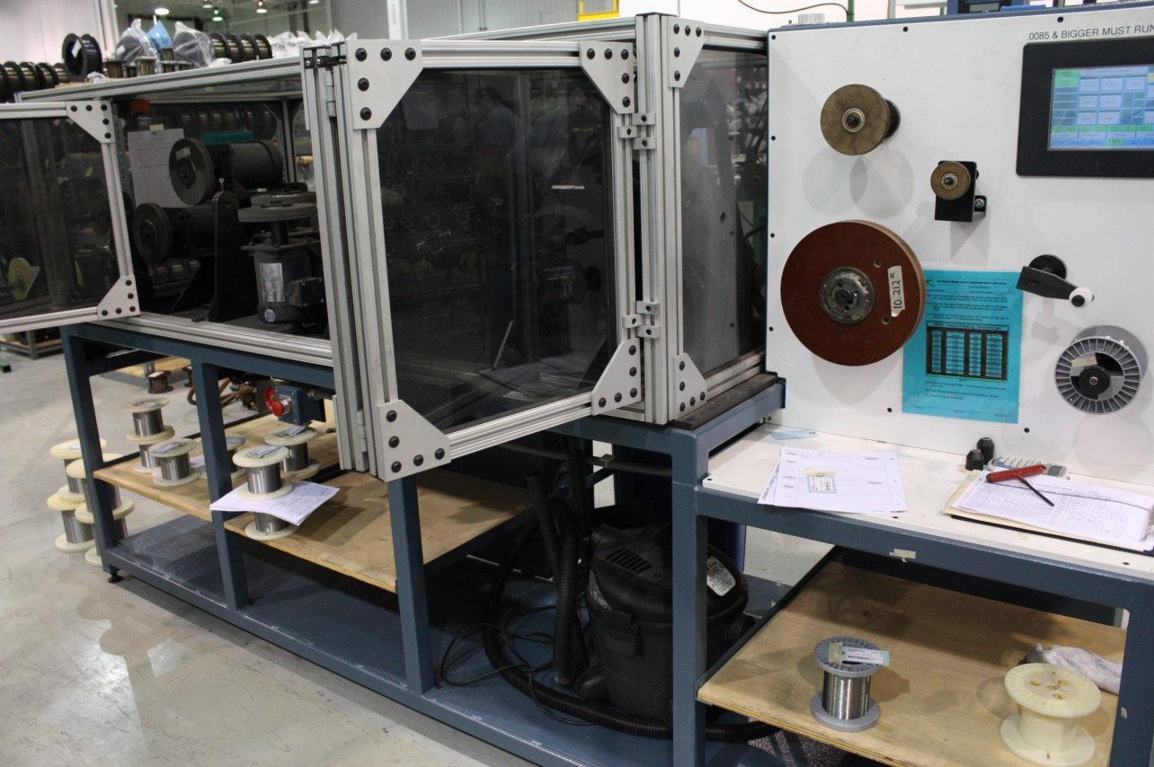
In this picture, Fort Wayne Metals’ old abrasive system that needs to be replace with micro-blasting unit from Comco equipments (See in the Appendixes for Comco’s Equipments and Specifications).
The old systems that Fort Wayne Metals uses have eight abrasive wheels to polish the nitinol wire. The eight abrasive wheels are evenly spaced by degrees. The first two wheels are 180 degrees apart from each other (polishing the top and bottom of the nitinol wire). The second sets of wheels are 90 degrees from the first two wheels (polishing the two sides of the nitinol wire). The third set is 45 degrees from the second set of wheels in quadrants two and four (polishing the nitinol wire from 45 degree). The last set of two wheels is 90 degrees from the third set (polishing the nitinol wire from the other two sides by 45 degrese) (See in the Appendixes for picture).
The operator first moves all abrasive wheels to the homing coordinate with the PLC. Then, the operator turns on the laser for abrasive wheels alignment. The first wheel then moves down to touch the laser, but backs off by thousandths of an inch. The operator repeats the process for the rest of the seven wheels. He then takes the nitinol wire from the starting spool and strings it into the first wire die on the windows of the machine fame. Next, he positions the nitinol wire across the eight abrasive wheels and out the last wire die on the end spool side. The operator then starts up the machine. The eight abrasive wheels starts to polishing the nitinol wire as it is run across the wheels.

1st Proposed Layout
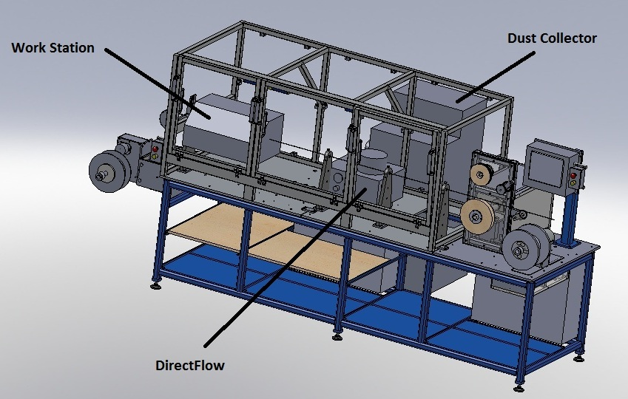
Starting spool end spool
We decided to use the preexisting machine frame and replace only the polishing wheels inside the windows. We also decided to use Fort Wayne Metal’s wire die. We did not want to limit future designs with space so we kept the two base plate designs.
At the time of proposing, the air wipe system had not been fully designed, but the blasting unit was selected. At this stage, we were researching the cleaning process for the wire. We had three choices: supersonic cleaning, dry ice cleaning, and ExAir super air wipes.
The DirectFlo, which controls abrasive media flow, could be placed inside the windows which would contain any escaping dust, or under the windows to allow more space in the machine frame. The media that we decided to use for blasting the wire was aluminum oxide based on Fort Wayne Metals lab test results. Aluminum oxide had the best surface finish.

1st Proposed Wire Path
Note: starting from where the wire is taken off the spool
- First wire guide
- Workstation with blasting nozzle array inside
- Dust collector hose run behind the workstation
- Second wire guide
- DirectFlo
- Third wire guide
- Air Wipe
- Fourth wire guide

2nd Proposed Layout
Workstation Fixture
First Wire Guide Workstation Adjustable Fixture for the Nozzles Array Second Wire Guide Left Base Plate

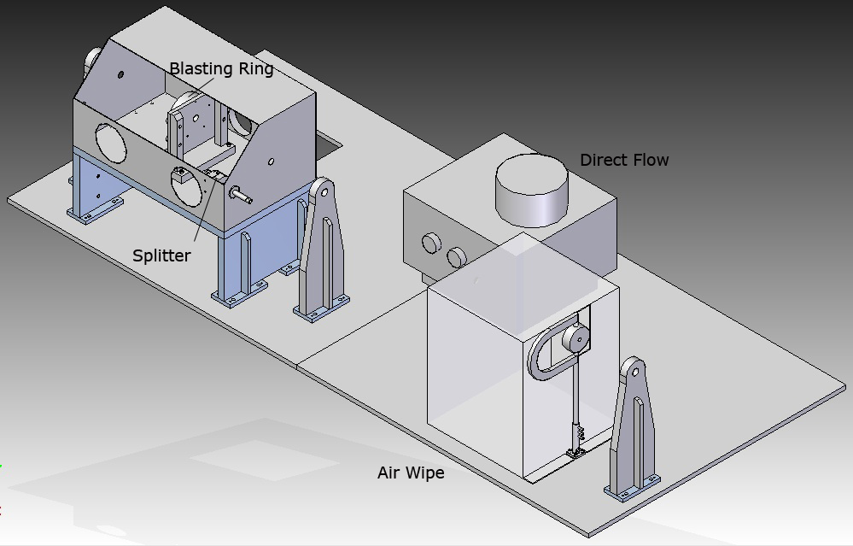

Polycarbonate Box Exair Super Air Wipes Aluminum 8” (1/4 NPT) Air Wipe Base Last Wire Guide
Right Base Plate
In this layout, we decided to use the ExAir super wipes as the cleaning process and place the DirectFlo inside the machine fame. The reason that we decided to use ExAir super wipes because it is cheaper than supersonic or dry ice cleaning and easier to install.
We also cut two 0.875 inch holes on each side of the workstation for the wire to enter and exit.
We took the design from Fort Wayne Metal’s left base plates but used a hole layout specific to our fixtures. We also cut an 11” by 14” opening in our left plate so the vacuum hose, compressed air pipe and electrical wiring could enter the system. (See Appendixes for BasePlate Design).
Placing the DirectFlo inside the machine frame prevents the media from spilling outside the machine frame. It will also be easier for the operator to reload media as compared to putting the unit under the base plates. The DirectFlo is not secured to base plates because its weight will hold it in place.
We designed the workstation base fixture using ½” thick low carbon steel. The workstation base’s U-shape design reduces the cost and time to fabricate the fixture. The base elevates the workstation 10” off the baseplate allowing wire to enter near the center of the box. The screws holding all pieces together are the same screws that support the wire guides, preventing the cost of extra screws and retaining design continuity. The 8” gussets help support the two vertical plates (See Appendixes for Gusset Design). The bottom of the two vertical plates is held together by the same bases used for wire guides. The workstation top plate is laid on top of the two vertical plates and held down by 12 screws. The workstation sits on the top plate and is located with 8 screws (See Appendixes for the Workstation Vertical and Top Plate Design).
Since the wire die has a fixed height, the design for the blasting ring fixture needs to be adjustable to compensate for any differences between the heights of other items (See Appendixes for Close Up the Blasting Ring Fixture). The vertical plate has five holes to bolt the blasting ring and front plate together. The vertical plate contains two slots which provide height adjustment. When the operator adjusts the vertical plate to desired height, the ½” shoulder bolts are screwed down to clamp the vertical plate and vertical supports. The vertical supports are bolted to the blasting ring base plate. And the blasting ring base plate is bolted down through the workstation and into the top workstation plate (See Appendixes for Vertical Plate, Blasting Ring Base Plate, and Blasting Ring Vertical Support).
We also designed an adapter for the splitter because the pre-made hole on the workstation was bigger than the splitter cylinder. The adapter’s purpose is to hold the splitter in place while the machine operates (See Appendixes for Close Up for the Adapter). The splitter’s bracket is bolted to the workstation front. A spacer provides alignment and stability between the workstation and splitter (See Appendixes for Close Up of the Spacer) (See Appendixes for Spacer and Splitter Adapter Design).
The wire then exits the Workstation and abrasive blasting is complete. The next step is to clean any remaining particles off the wire with compressed air. Wire enters a 1/8” thick polycarbonate box and through the ExAir air wipes (See Appendixes Unused Layout, Models, and Drafts). The polycarbonate is designed to hold the dust blasted from the air wipe (See Appendixes for ExAir Super Wipes Description). The ExAir super air wipe is supported by an 8” aluminum pipe (1/4” NPT both ends). The aluminum pipe fits into the air base and is clamped by three screws (See Appendixes for Air Base). At the other end of the aluminum pipe, a flex compressed air hose is connected to the aluminum pipe’s ¼” NPT. The flex hose is then run out of the side of the air wipe base.
We also needed to figure a way to plug all the holes in the workstation so particles will not be able to escape from the workstation. At this stage, we were thinking about using polycarbonate to cover the two front holes of the workstation.

Final Layout to FWM

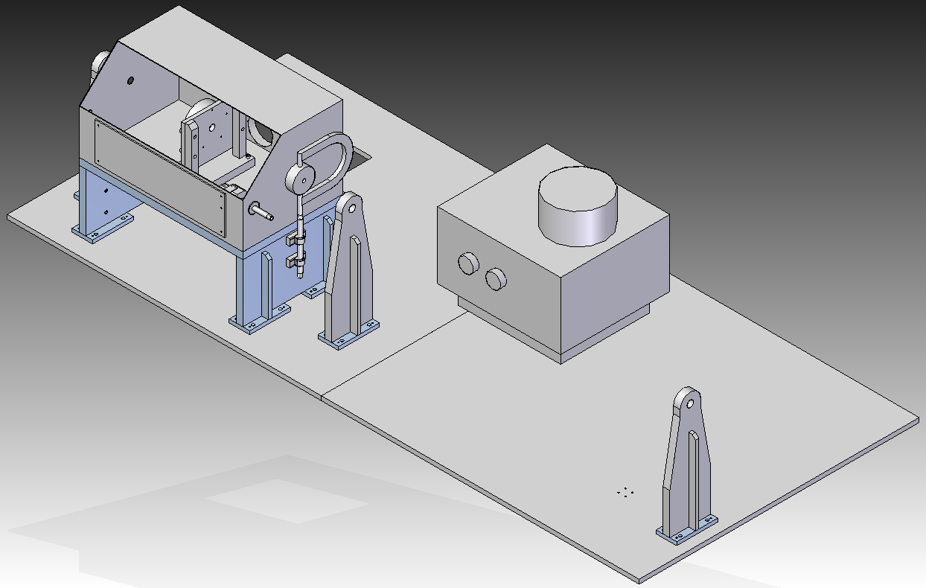
Sheet Metals Cover Vibration-Damping Clamps (Thermoplastic Rubber)
On April 1st 2011, our group and Fort Wayne Metals engineer Jamie Weller have a meeting about our 2nd proposed layout. Jamie did not like air wipe box design because of its increased time to fabricate and increase cost. Jamie also wanted the ExAir closer to the workstation. He was also concerned that the air wipe base would leak air. Jamie suggested that we move the ExAir super air wipe next to the workstation vertical plate. He also suggested that we use welded vibration-damping clamps to support the aluminum pipe.
Our team decided to use bolted vibration-damping clamps instead because they are easier to install. We ordered the bolted vibration-damping with an inside diameter .05” smaller than our aluminum pipe. The clamps provide some tolerance because the inner rubber is able to expand.
During operation, the ExAir air wipe will force media back into the workstation for the vacuum to collect.
We tried to find plugs to fit the two 5” holes in front of the workstation, but were not able to find anything that large. We decided to use sheet metal to cover the two 5 inch hole. Fort Wayne Metals has sheet metal on-hand which makes the solution convenient. We used five bolts and nuts to hold the sheet metal and workstation together.

Construction
Most of the fixture components were fabricated by Fort Wayne Metals. Matt Patterson and Hai Le decided drill all the holes on the workstation. The assembly of all the fixtures and equipment will be done by Fort Wayne Metals.

Part Function

Comco Blasting Equipment
Aluminum Oxide Media
Aluminum Oxide is used to condition the surface of the wire.
DirectFlo
The DirectFlo holds the abrasive and pumps it into the system using a single line. Users can manually control the pressure and what else?
Splitter
The splitter splits the single media line coming from the DirectFlo into five separate lines for the blasting ring.
Blasting Ring
The blasting ring blasts wire from 5 directions to ensure media is hitting the wire uniformly.
Workstation
The workstation contains the blasting process controlling the dust.
Dust Collector
The dust collector connects to the workstation and vacuums dust out of the system.

ExAir
Air Wipe
The air wipe uses compressed air to blast any media remaining on the wire after the initial blasting process. The media is blasted back into the workstation.

Base Plate
Left Base Plate
The entire blasting process fits onto the left base plate.
There is an opening near the back of the base plate for the dust collector hose, compressed air hose, and electrical wiring.
Right Base Plate
The right base plate contains no fixtures for our current design besides the DirectFlo. The plate is open for any additional processes or fixtures that may be required in the future.

Wire Guides
Wire guides prevent the wire from going off-track if the wire or a part breaks.

Workstation Base
The Workstation Base assembly elevates the workstation 10 inches off the baseplate allowing wire to pass through the center. The base is also rigid enough to not move when the process is exposed to vibration.
WSB Top Plate
The top plate is what the workstation sits on. 8 holes lock the workstation and blasting ring assembly to the top plate.
WSB Vertical Plates
Vertical plates hold the top plate in place, one plate is also used to hold the ExAir air wipe unit.
WSB 8in Gussets
Gussets provide extra strength and rigidity to the assembly by giving the vertical plates ‘backbones’.
Wire Guide Mounts
Previously designed wire guide mounts are used as the ‘feet’ of the Workstation Base. The wire guide mounts can be interchanged with Wire Guides or the Workstation Base. Therefore, even if the Workstation Base will no longer be used, its ‘feet’ will still be usable in other applications.

Blasting Ring Assembly
The Blasting Ring Assembly sits inside the workstation and supports the Comco Blasting Ring. It is designed with an adjustable height which will compensate for thickness variations and allow
more flexibility in other processes.
BR Vertical Plate
The blasting ring attaches to the vertical plate. The vertical plate is bolted to the vertical supports using shoulder bolts to clamp the adjustable slide.
BR Vertical Supports
Two vertical supports hold the vertical plate.
BR Base
The base holds the vertical supports, and locks to the workstation and Workstation Base Top Plate.

Splitter Mount
The splitter brings the abrasive media line into the workstation while splitting it into 5 lines. Parts are required to hold the splitter onto the workstation and limit vibration.
Splitter Adapter
The adapter holds the splitters main pipe in place while plugging the workstation’s hole for the vacuum.
Splitter Spacer
The spacer connects the splitter bracket to the workstation side, centering the splitters main pipe into the workstation hole.

Workstation
The workstation wasn’t built specifically for our design, so we needed to make it work by adding holes and plugging useless features.
Sheet Metal Cover
A piece of sheet metal covers two large holes in the front.
Plug for small hole
A plug purchased from McMaster.com fits inside a small hole on the side.
We drilled 8 holes in bottom, 5 holes in front, and 2 holes on side
13 small holes were drilled for fixtures, and larger holes were drilled on the side for wire to run through the workstation.

ExAir Mount
The ExAir Air Wipe must reach the wire at 16 inches off the base plate.
8” Aluminum Pipe
McMaster.com has many pipes available, their aluminum pipe comes with two NPT threads for easy attaching with other hoses. One side of the pipe attaches to the ExAir unit, the other attaches to a flexible compressed air hose. The pipe also supports the air wipe, holding it in place.
Spacers
Spacers distance the rubber holders giving the air wipe head clearance from the workstation. Spacers fit between the Workstation Base Vertical Plate and Vibration-Damping Clamps.
Vibration-Damping Clamps
Clamps are used to hold the pipe; the clamps allow the air wipe’s height to be adjusted to the correct height.

Testing & Data Collection
We used Solid Edge to test our workstation base for deflection by assembling the parts together in Solid Edge and using the programs finite element analysis feature. The input for the finite element analysis was a 100 lb distributed load because the workstation weights an initial 50 lbs, plus we are factoring for any extra equipment that may be included. The result was 1.302e-4 inches deflection for top plate (See Appendixes on Deflection Analysis). The analysis also verified the base was strong enough to support our equipment. We used ½ inch thickness low carbon steel for the fixture which able to the handle the load with easy. The deflection was important because the wire path have to all with the fixture wire guide.

We were not able to reach the wire smoothness testing phase because of time constraints. Our proposed method of testing to determine pressure and wire feed rate input values would be to first conduct a Design of Experiment (DOE) to hone in on a successful combination range. Afterwards, we would test within the honed range for the ideal combination of blasting pressure and wire feed rate.
For the initial DOE, we suggest at least 5 combination runs on the following settings:
Pressure (psig): 40, 65, 90, 115, 140
Wire Feed Rate (fpm): 70, 115, 160, 205, 250
For pressure, we use equal values within the minimum (40) and maximum (140) capacity of the DirectFlo.
For wire feed rate, the current polishing machine runs at 70 fpm, we do not want this process to run slower than the current machine so we are not testing anything lower than 70 fpm.
In order to conduct the DOE, the wire surface must be rated with a ‘desirable’ rating. We recommend using a scale from 0-100, 0 being totally undesirable, 100 being totally desirable.
Once all combinations have been tested, we would plug the data into a statistics program such as Minitab to analyze the results and find the most ‘desirable’ combinations of pressure and feed rate.

We would then conduct new tests in a range around the most desirable combination. Another DOE could be implemented, or input values could be held constant to configure a graphical analysis. We would combine both the constant feed rate and constant pressure graphs to form an equation which will use feed rate and pressure as inputs, and desired surface finish as an output.
Based on Comco’s document on How to Achieve Uniform Texture (see Appendixes on Comco Equipment and Specifications), we concluded the following:
At a constant wire feed rate, we speculate uniformity to be small with a pressure too low or high. If the pressure is too low, there won’t be enough media hitting the surface of the wire as it passes. If the pressure is too high, a large volume of particles will cause too many surface indentations. For the same reasons, we speculate uniformity will be small when the pressure is held constant, and the pressure is too low or high as well.
We would use the Fort Wayne Metals test labs to visually inspect the wire with a microscope. We need the test the wire for smoothness and cleanliness of the wire. We will also send the wire to a company in Michigan for more accurate laser inspection. We speculate the end formula and graphs to look like:
S = aP^{x} + bF^{y} + C S = smoothness, P = pressure, F = feed rate
a,b,x,y,c = constant
Fig1.1 Constant feed rate Fig1.2 Constant Pressure
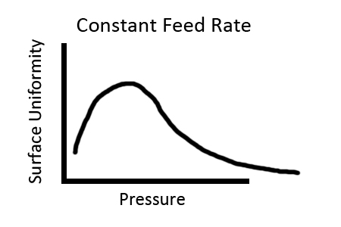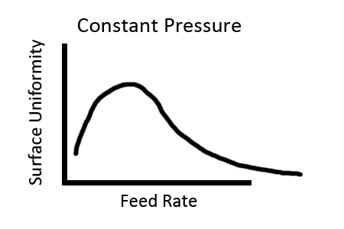

Overall Budget

System Components | Brand | Product Description | Part # | Weight(lb) | Dimensions | Qty | Price
Wire |  | Nitinol |  | N/A | N/A
Micro-Abrasive Blasting Unit | Comco | DirectFlo | DF1400-1 | 64 | 17"H x18"W x16"D with 3/8" line | 1 | $6,950.00
Blasting Ring Nozzle | Comco | Nozzle Array Assembly | SP1905 | N/A | 8"Ø x 7/8 width | 1 | $2,200.00
Abrasive Material | Comco | Aluminum Oxide |  | N/A | 10-150 micron
Dust Catch | Comco | Work Station | WS2200-1 | 50 | 24"W x 15"D x 12"H with 4"Ø outlet | 1 | $1,325.00
Continuous Air Dryer | Comco | Continuous Duty Air Dryer | AD5300-3 | 10 | N/A | 1 | $2,800.00
Vacuum | Comco | 1 HP Industrial Dust Collector | DC2100-3 | 250 | 4"Ø x 5'L | 1 | $4,800.00
Cleaning Ring Nozzle | ExAir | Compressed Air Cleaning Ring | 2450 | N/A | 1/2"Ø | 1 | $389.00
Machine Frame | FW Metals | Box the entire system is in. |  | N/A | N/A
Vibration-Damping Clamps | McMaster | Clamp the aluminum pipe | 11355T23 | N/A | N/A | 2 | $6.66
8" Aluminum Pipe | McMaster | Air | 44665K412 | N/A | N/A | 1 | $3.28
Locking Rigid Plastic Plug | McMaster | Plug | 85985K21 | N/A | N/A | 1 | $8.02
 |  |  |  |  | Total Costs |  | $18,481.96

Conclusion & Recommendations
With the suggestions from Jamie Weller, we were able to finalize our design for the micro-blasting system. Because we haven’t build the system to confirm everything will work well together, we are concerned that having the ExAir unit blowing directly into the workstation.
The blasting ring has two bolts which act as a wire guides to place the wire directly in the center of the blasting process (See Appendixes for the Blasting Ring). The compressed air blowing from the air wipe might be strong enough to enter the small opening affecting particle direction and speed. The change in particle direction and speed may create a non-uniform wire surface. Also, the dust collector vacuum may not be powerful enough to prevent dust from circulating, and media may escape through the workstation’s wire enter and exit holes.
We recommend that the testing phase goes beyond testing one wire gage. The equation might be related to gage sizes of the wire. After the first gage is tested and an equation is created, the next testing phase will test six gage sizes smaller or bigger. Once the results and equations are formed from the second test, the two tests’ equations will be compared to each other. If the equations deviate by small amount, the equation is likely to be the same for all gage sizes. Otherwise, the equation is different for each different gage sizes and testing for each gage used in this process must be conducted.
Design and setup of the process is within our group and Fort Wayne Metal’s capabilities. The implication of continuous blasting design has proven to be educational for both our group and Fort Wayne Metals; we gained design experience and FWM now has a way to make abrasive blasting possible.

List of References

[1] Nitinol Wire. (2011). Retrieved from htpp://www.fwmetals.com/nitinol-wire.php
[2] Nitinol General Information. (2007). Retrieved from http://www.imagesco.com/articles/nitinol/01.html
[3] Hawe, Kelly. Technical Support, Comco Inc., 2011.
http://www.comcoinc.com/support/contactus.cfm?page=contactus [2]
[4] Kay, Larry. Director of Technology, Fort Wayne Metals Corporation 2011.
http://www.fwmetals.com/
[5] Weller, Jamie. Fort Wayne Metals Engineer, Fort Wayne Metals Corporation 2011.
http://www.fwmetals.com/
[6] “Air Wipes”, Exair.com, 2011.
http://www.exair.com/enUS/Primary%20Navigation/Products/Air%20Wipes/Pages/Air%20Wipe%20Home.aspxhttp://www.fwmetals.com/
[7] http://www.mcmaster.com/#

Appendixes

Close Up of the Spacing and Splitter Adapter

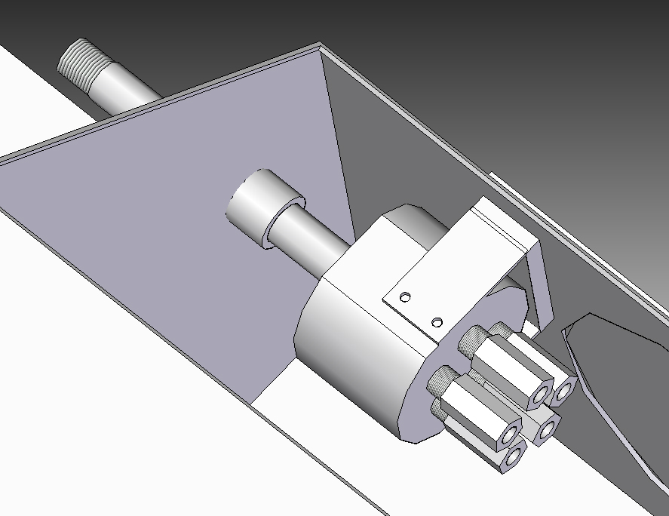

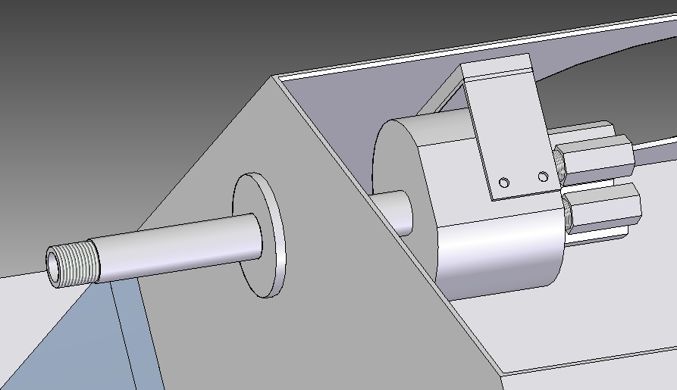

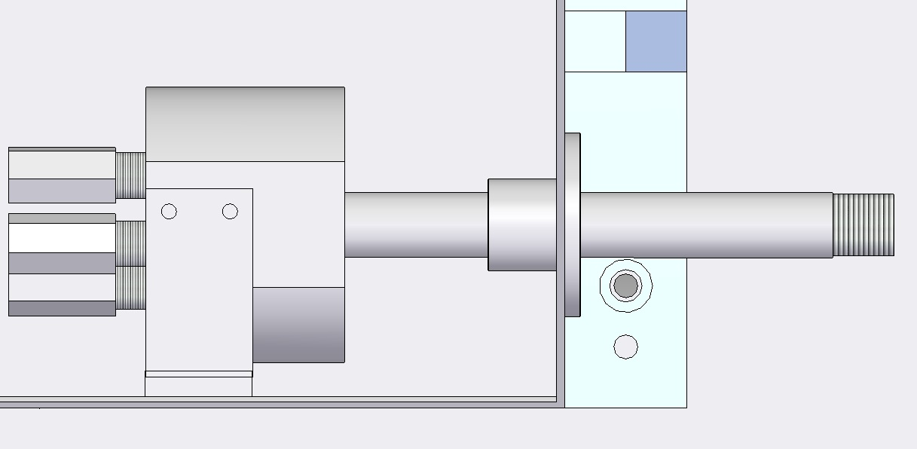

Close Up of the Nozzle Array Fixture
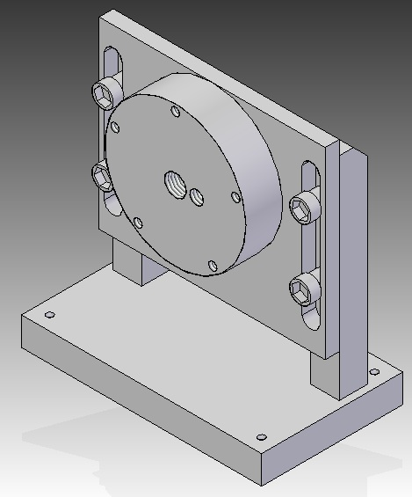

Close Up of the Blasting Ring
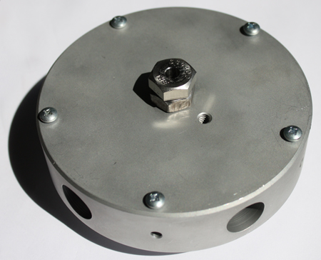

Blasting Ring Wire Guide
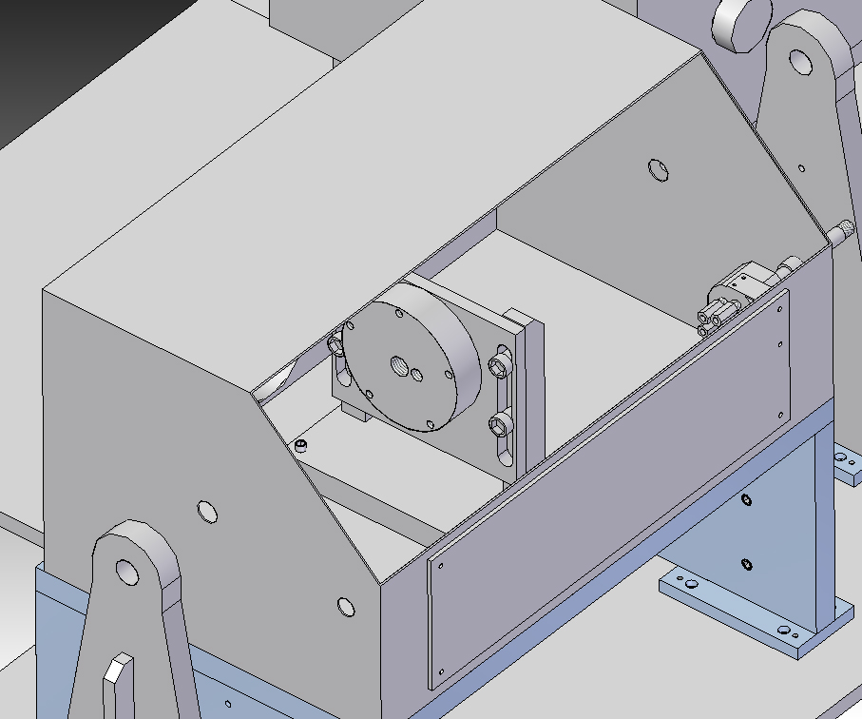

Solid Models and Drafts

Left Base Plate (Solid Model)
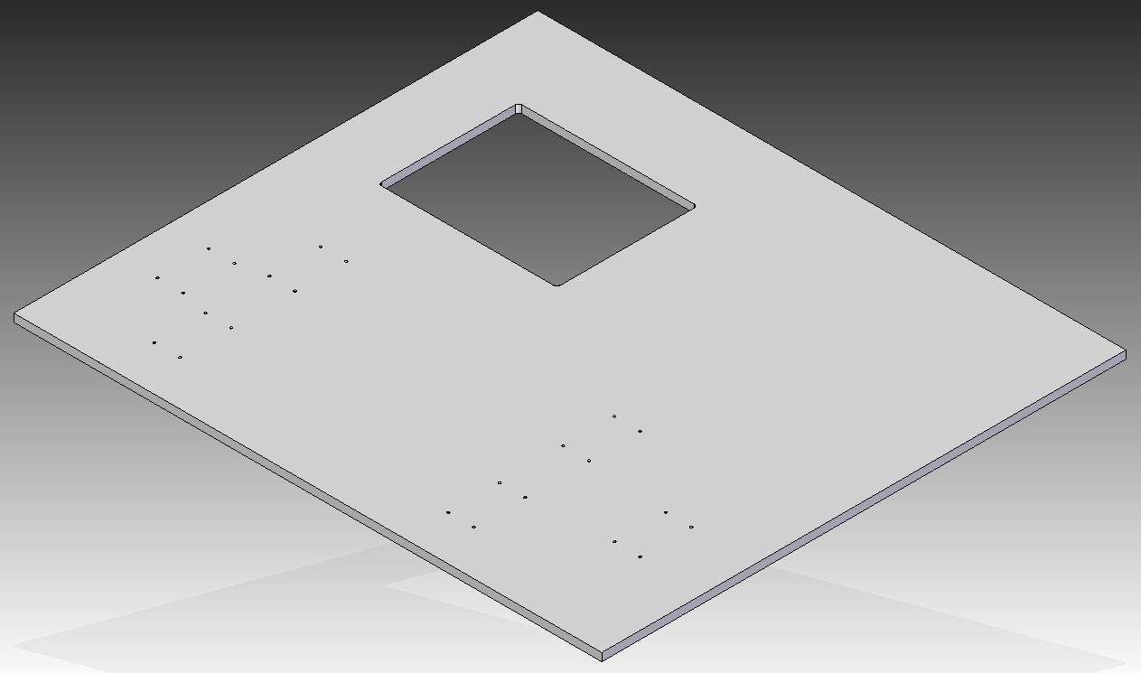

Left Base Plate (Draft)
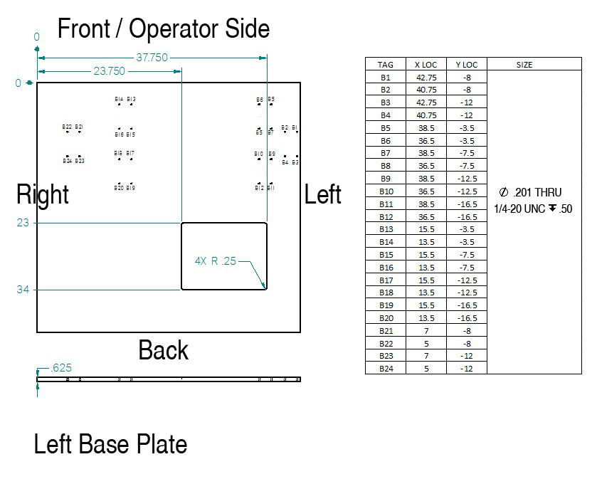

Right Base Plate (Solid Model)
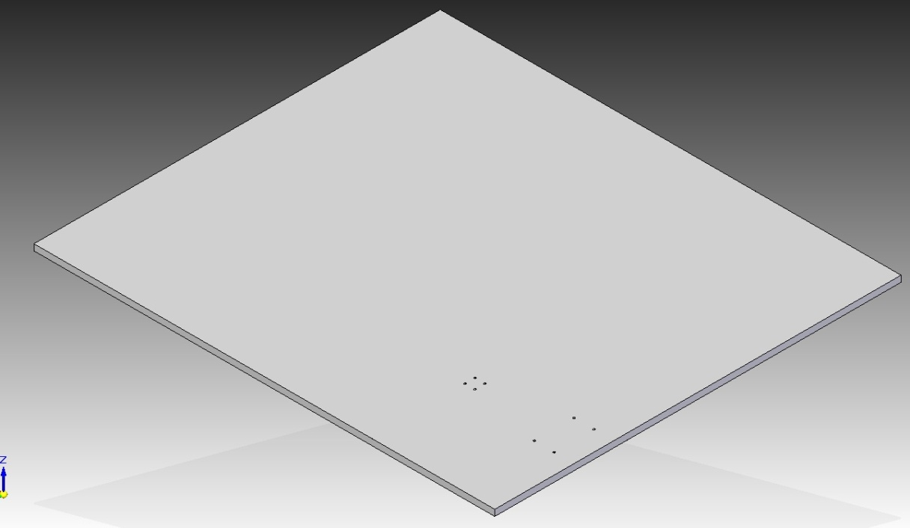

Right Base Plate (Draft)
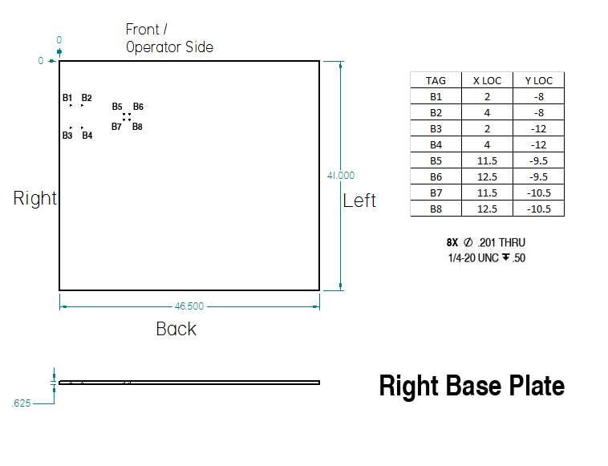

Workstation Top Plate (Solid Model)
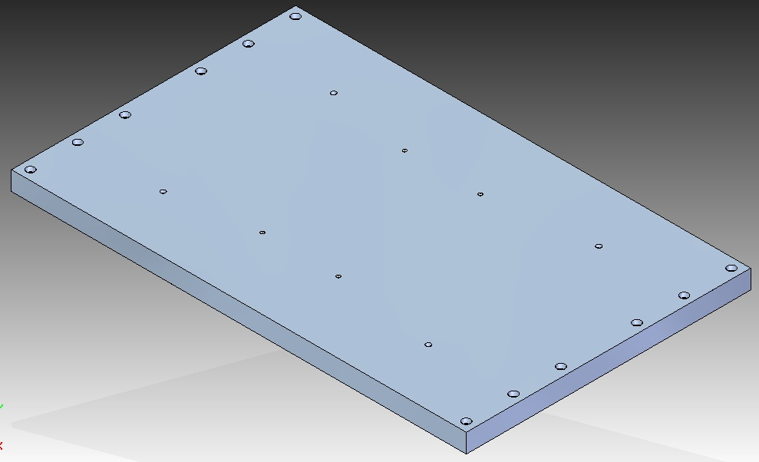
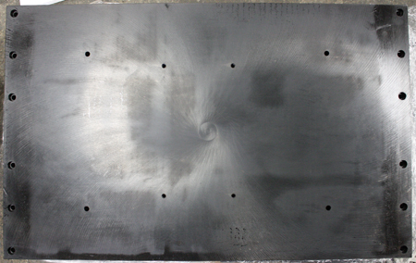

Workstation Top Plate (Draft)
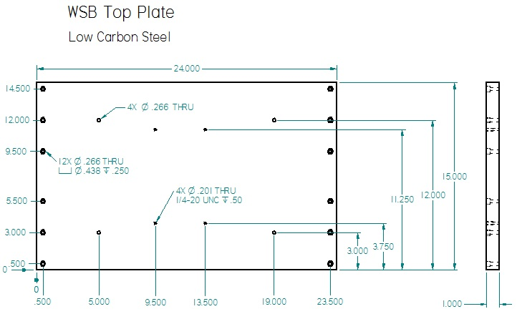

Workstation Left Vertical Plate (Solid Model)
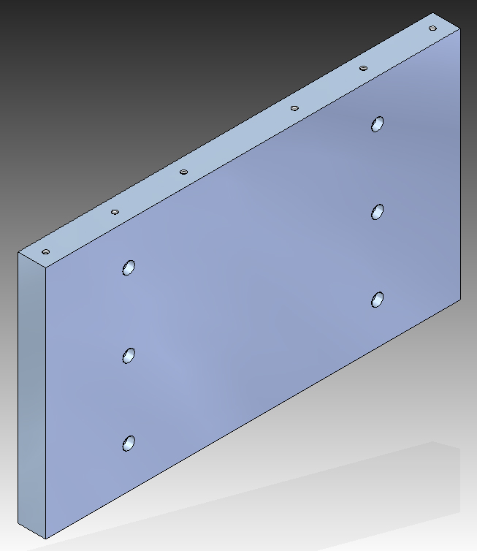
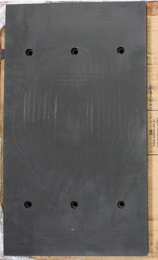

Workstation Left Vertical Plate (Draft)
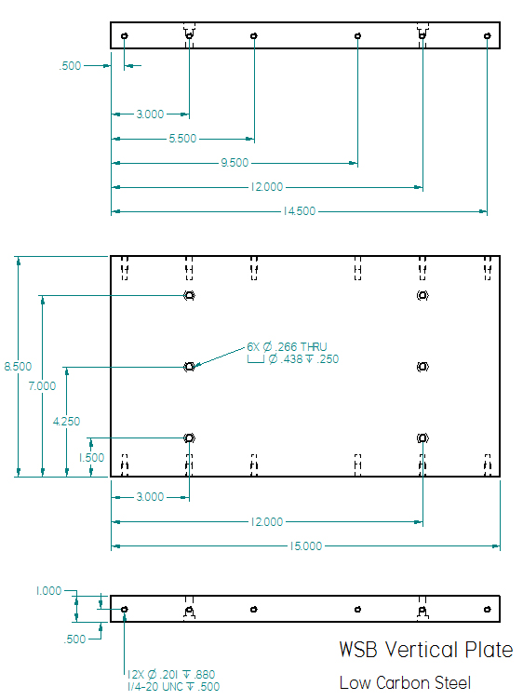

Workstation Right Vertical Plate (Solid Model)
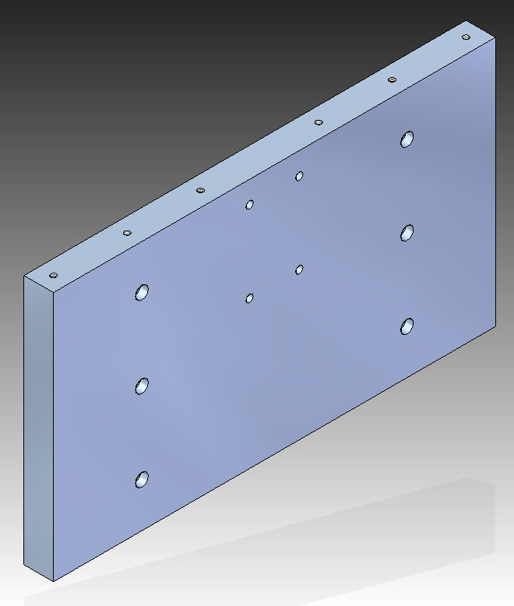

Workstation Right Vertical Plate (Draft)
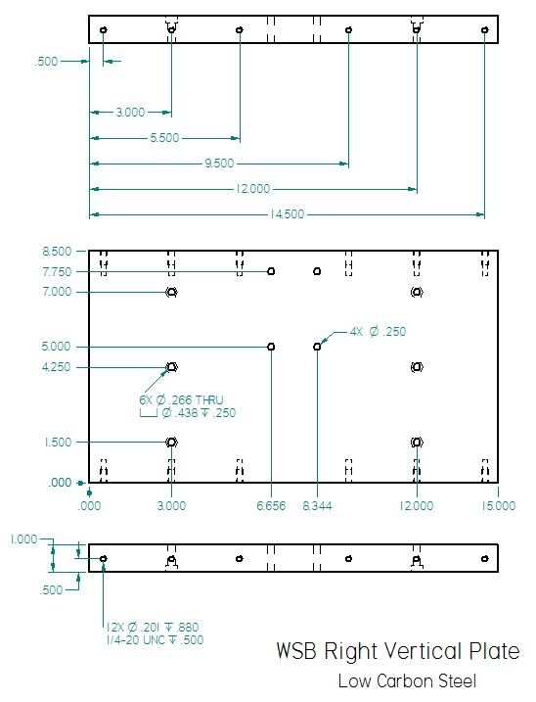

Workstation 8 inch Gusset (Solid Model)
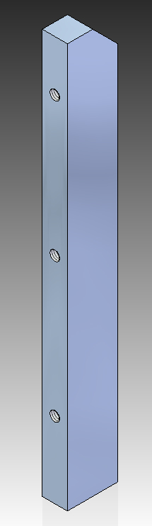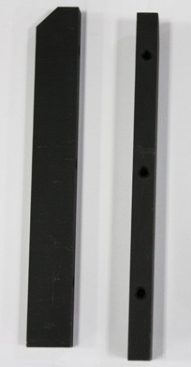

Workstation 8 inch Gusset (Draft)
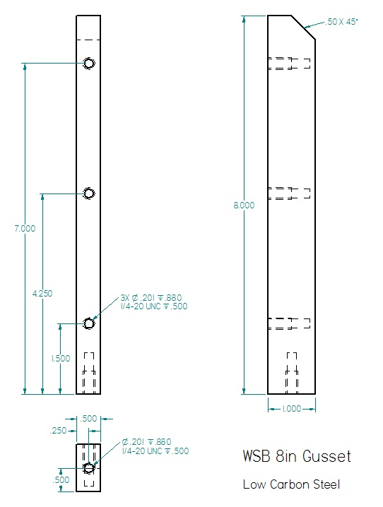

Wire Guide Mount – FWM-DCP3-6033 (Solid Model)
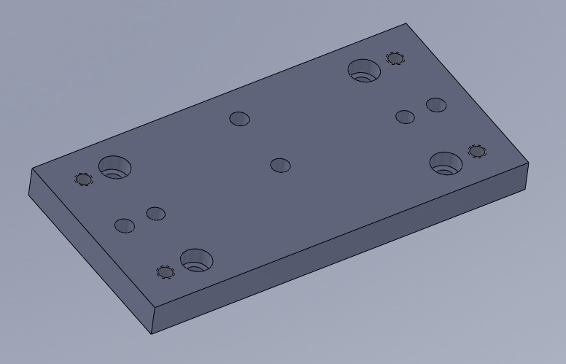

Wire Guide Mount – FWM-DCP3-6033 (Draft)
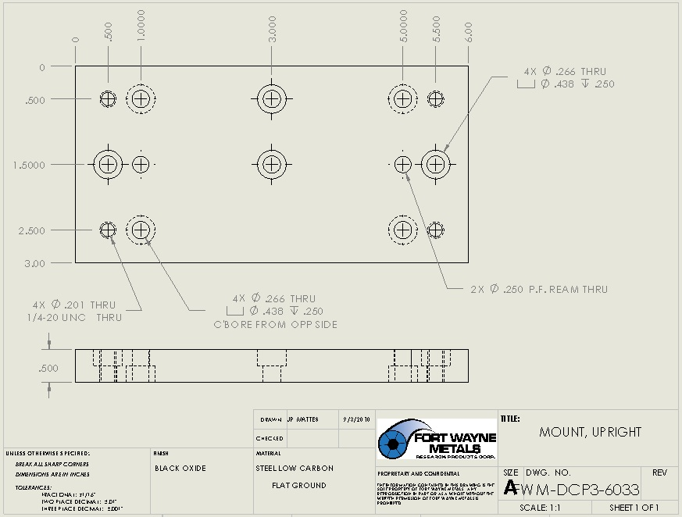
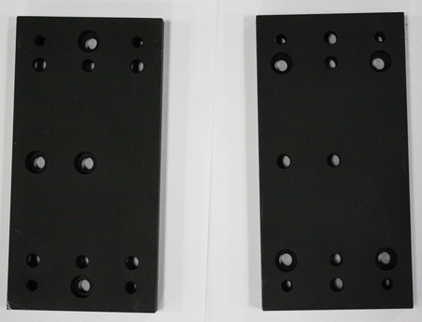

Blasting Ring Vertical Plate (Solid Model)
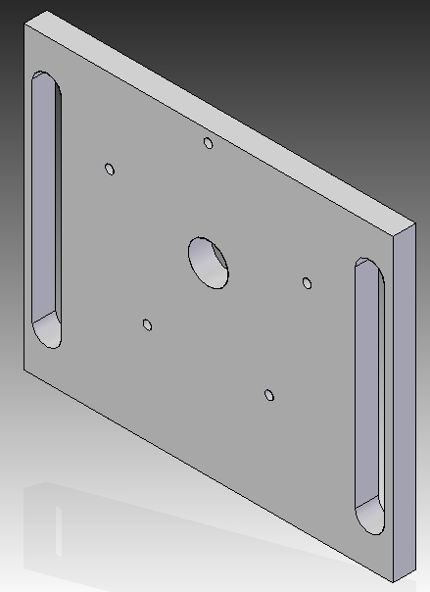

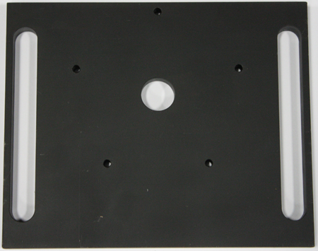

Blasting Ring Vertical Plate (Draft)
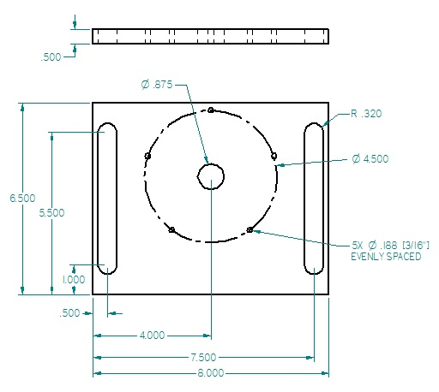

Blasting Ring Vertical Support (Solid Model)
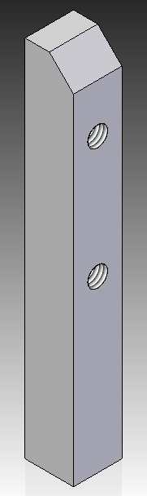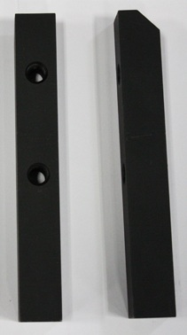

Blasting Ring Vertical Support (Draft)
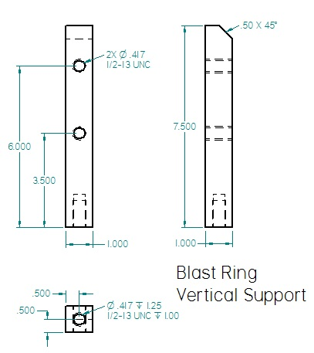

Blasting Ring Base (Solid Model)
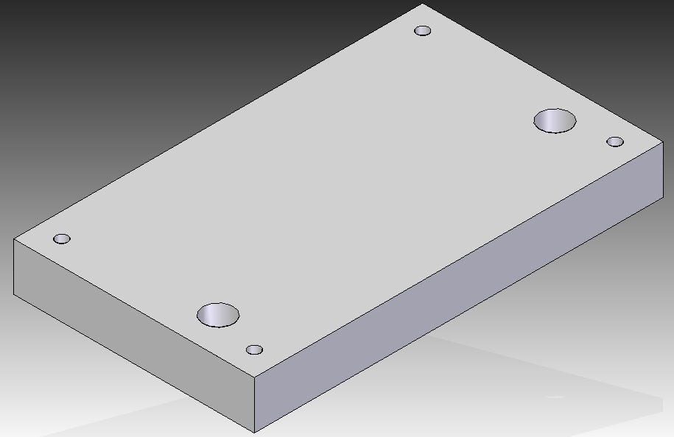
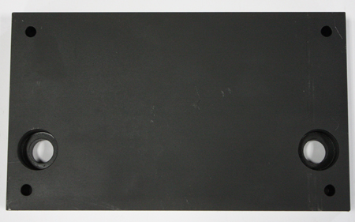

Blasting Ring Base (Draft)
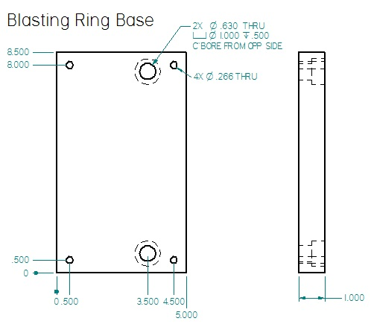

Splitter Adapter (Solid Model)
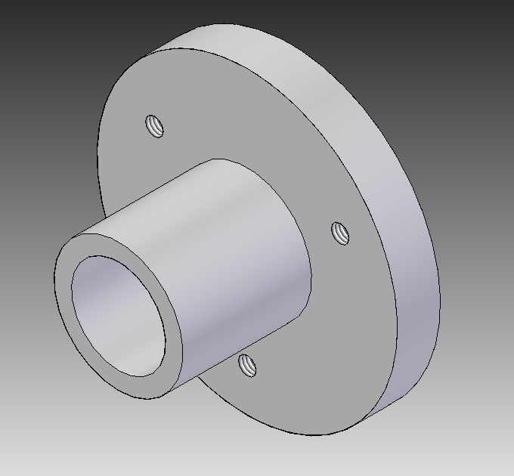
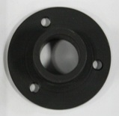

Splitter Adapter (Draft)
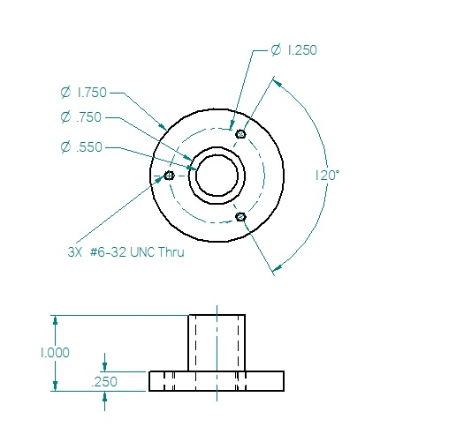

Splitter Spacing (Solid Model)
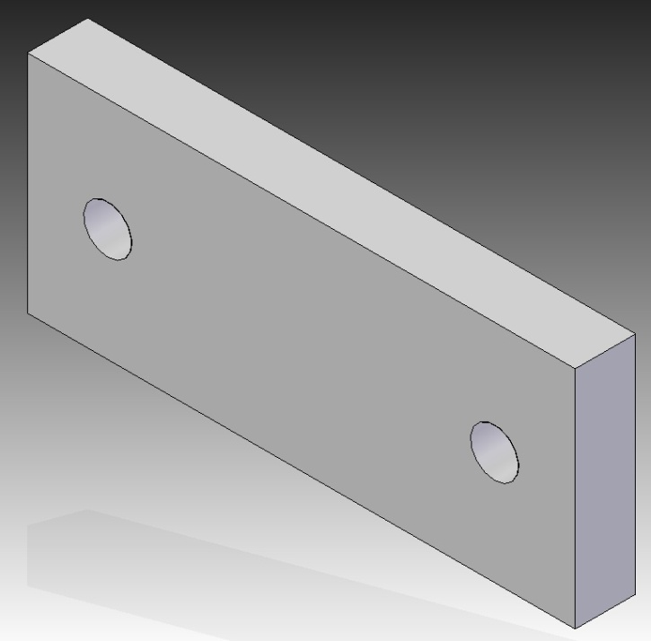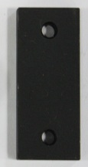

Splitter Spacing (Draft)
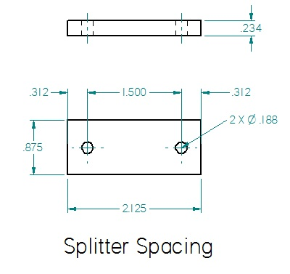

Sheet Metal (Draft)

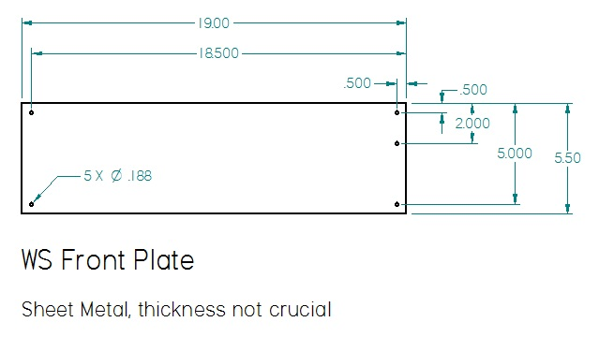

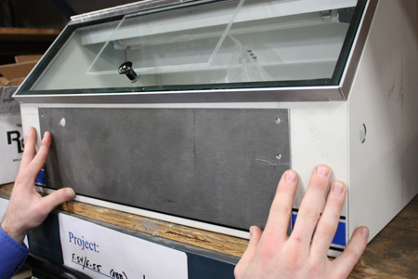

Comco Equipment and Specifications

Comco Nozzle Array
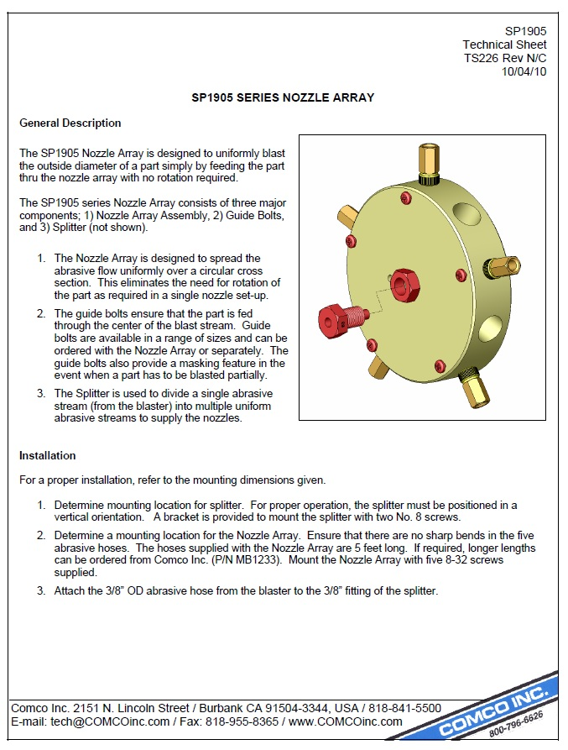

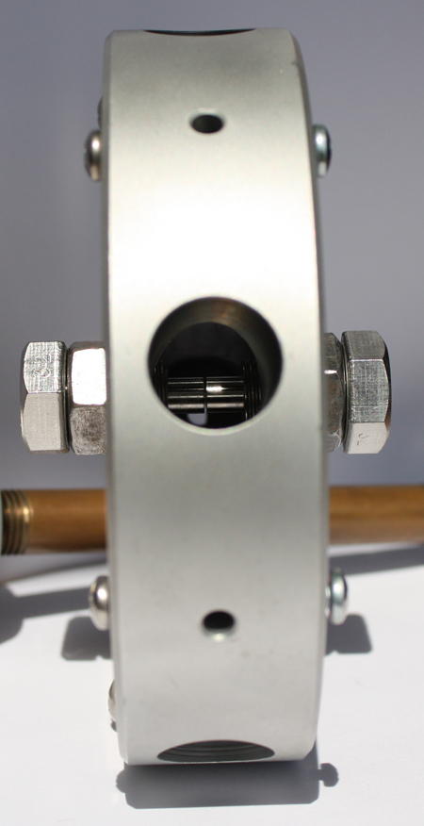

Comco Splitter
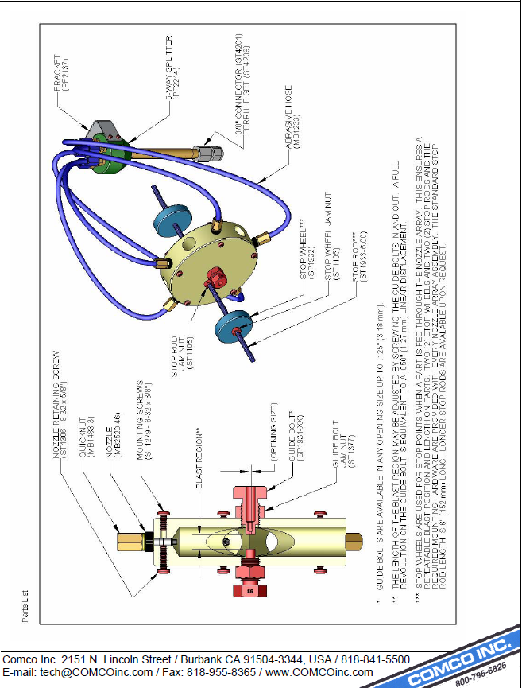
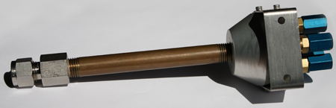

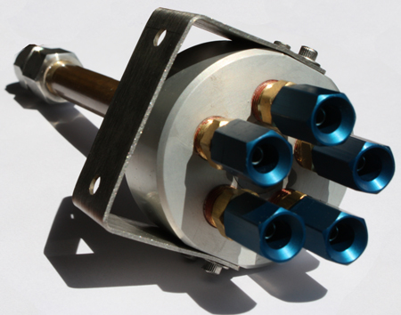

Comco Workstation Mounting
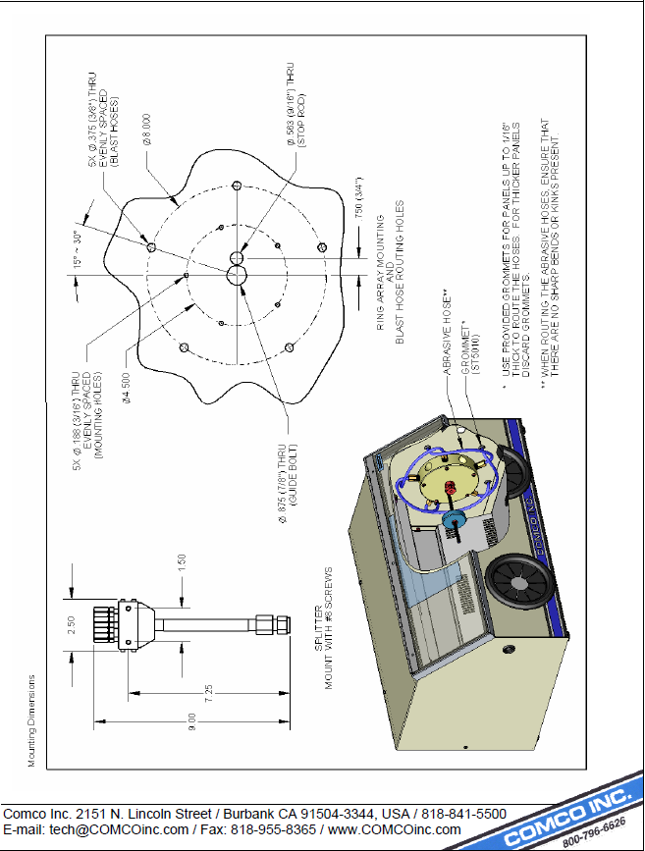

Comco How Uniform Texture is Achieved
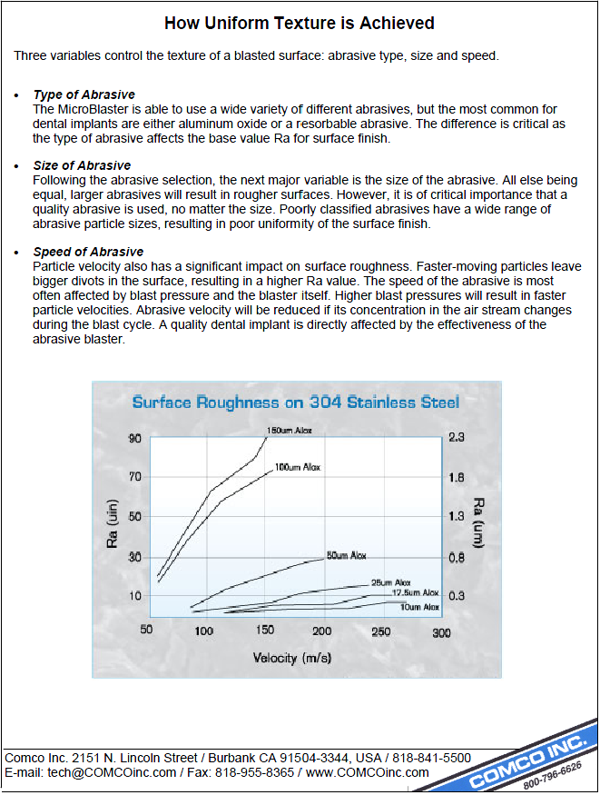

Comco DirectFlo and PowerFlo


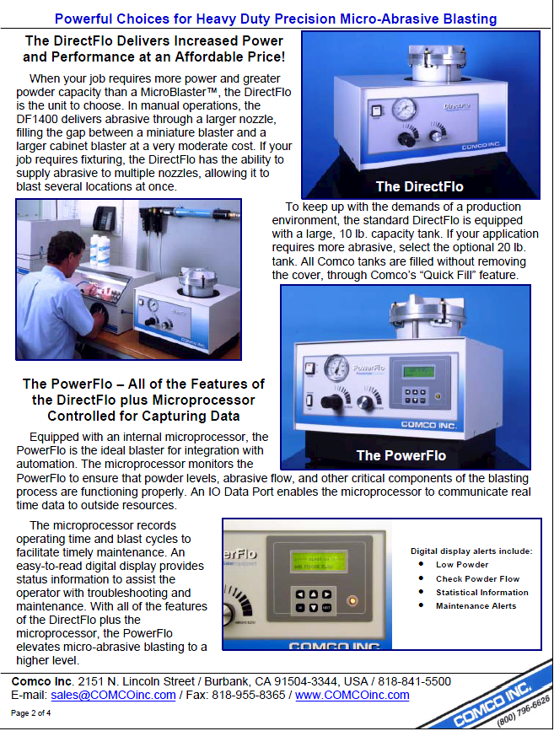

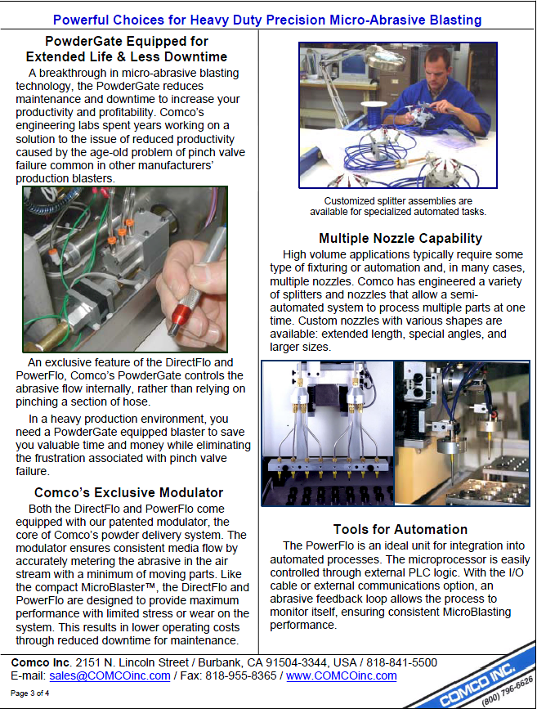

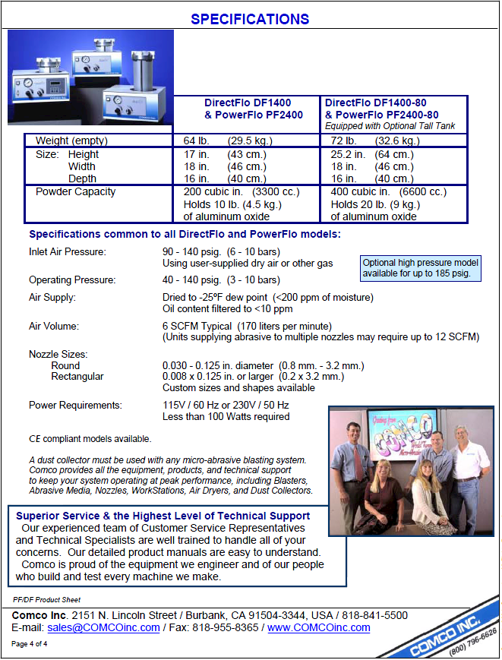

ExAir Super Air Wipes Description

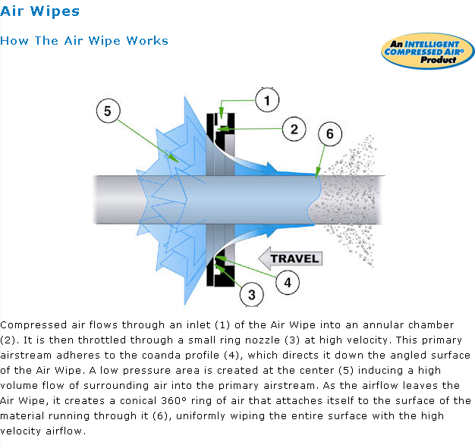
Notes: Pulled from manufacturer website: http://www.exair.com/en-US/Primary%20Navigation/Products/Air%20Wipes/Pages/How%20The%20Air%20Wipe%20Works.aspx
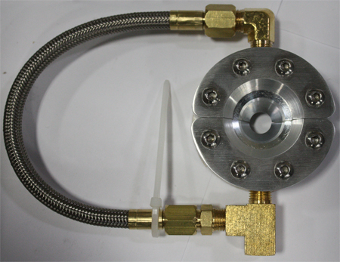

Fort Wayne Metals Abrasive Wheels Layout
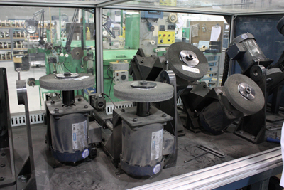

Abrasive Materials Laboratory Test by Fort Wayne Metals
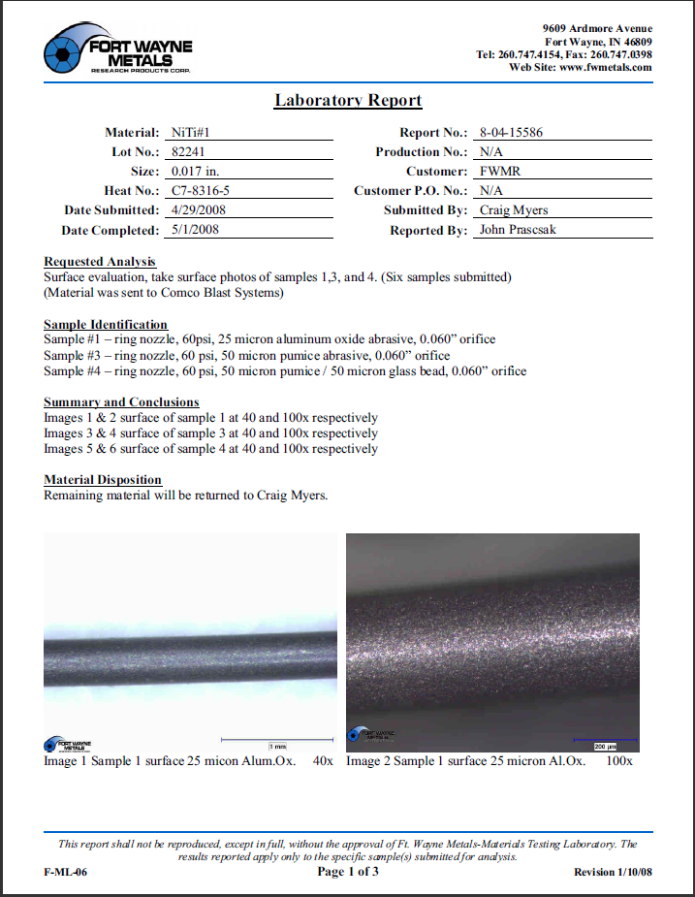

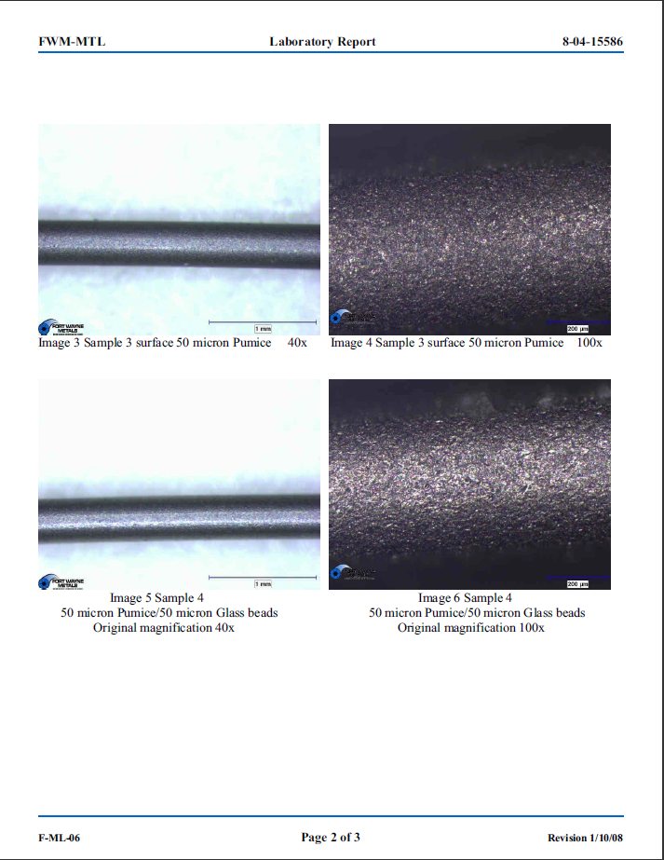

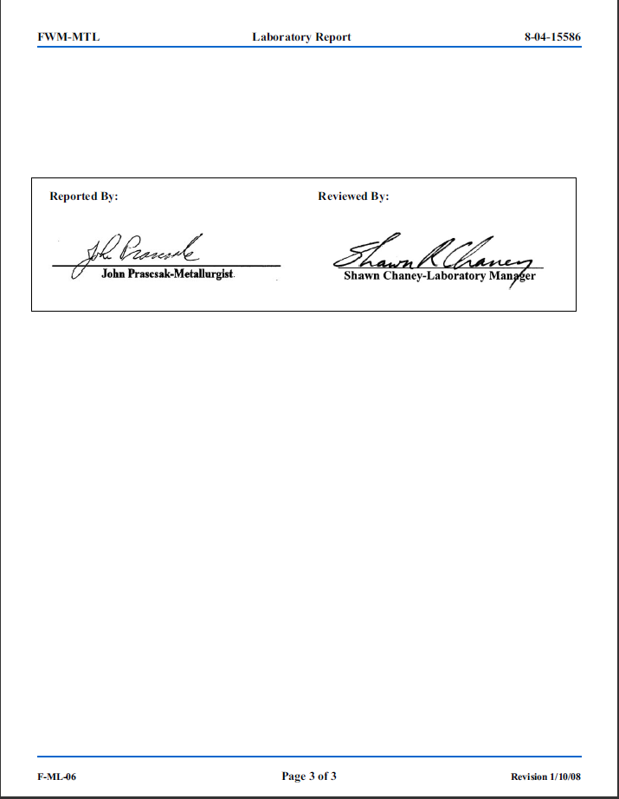
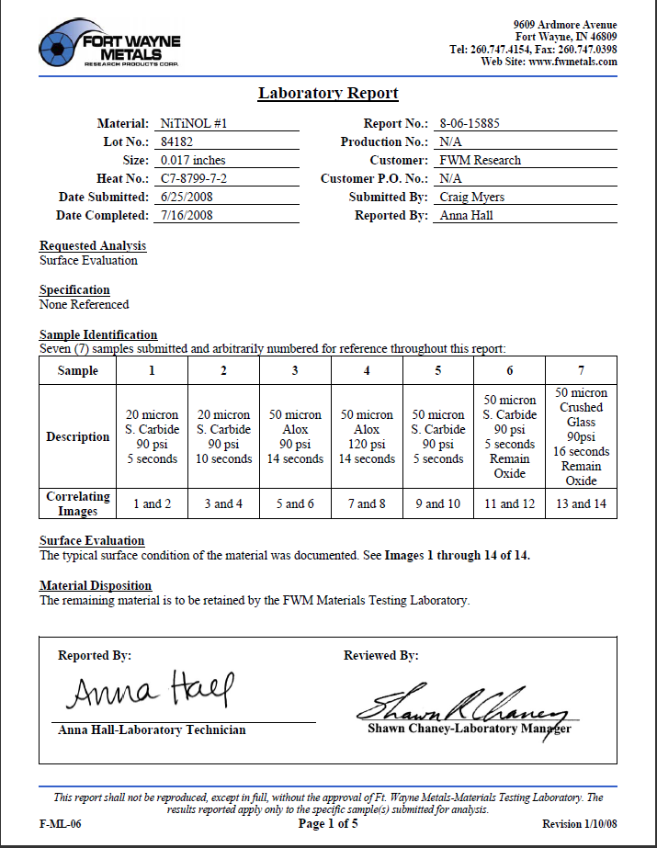
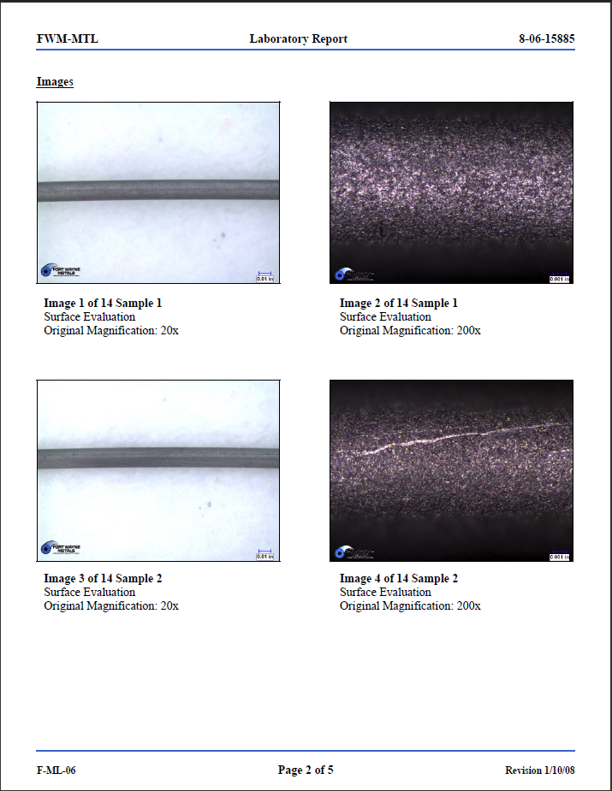
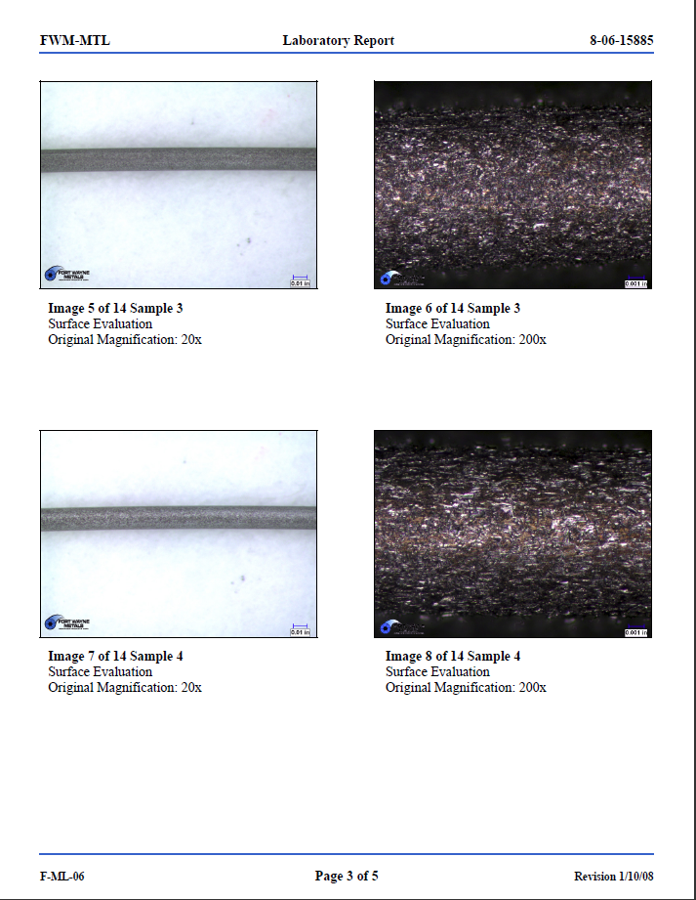
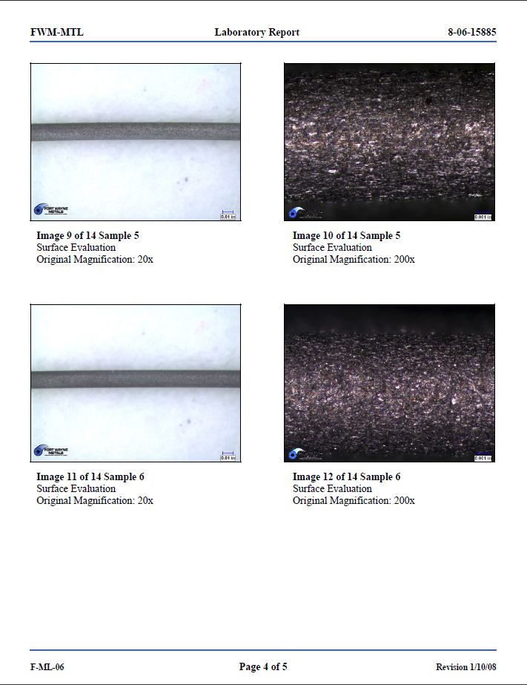

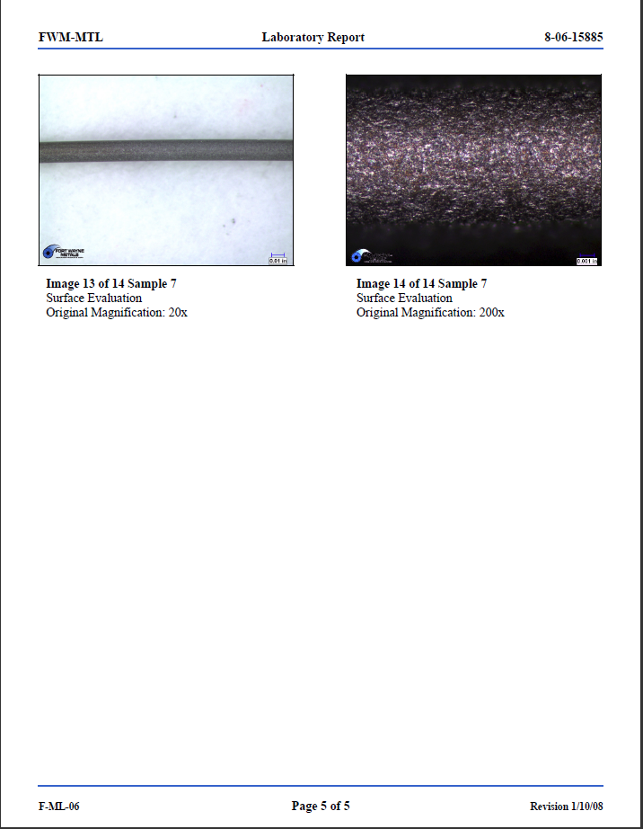

Deflection Analysis for the Workstation
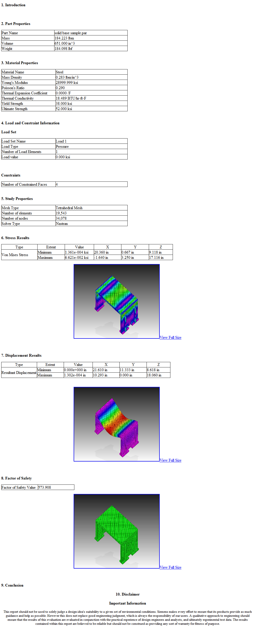

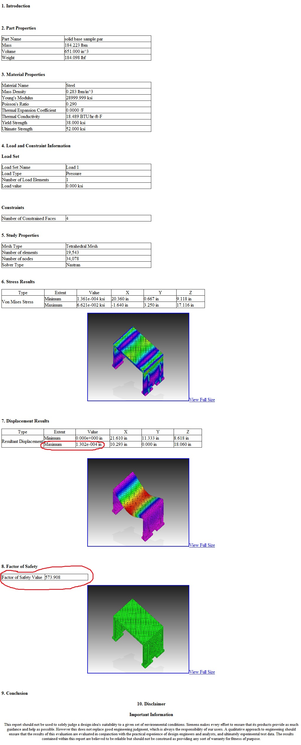

Unused Solid Layout, Models and Drafts

Layout Air Box

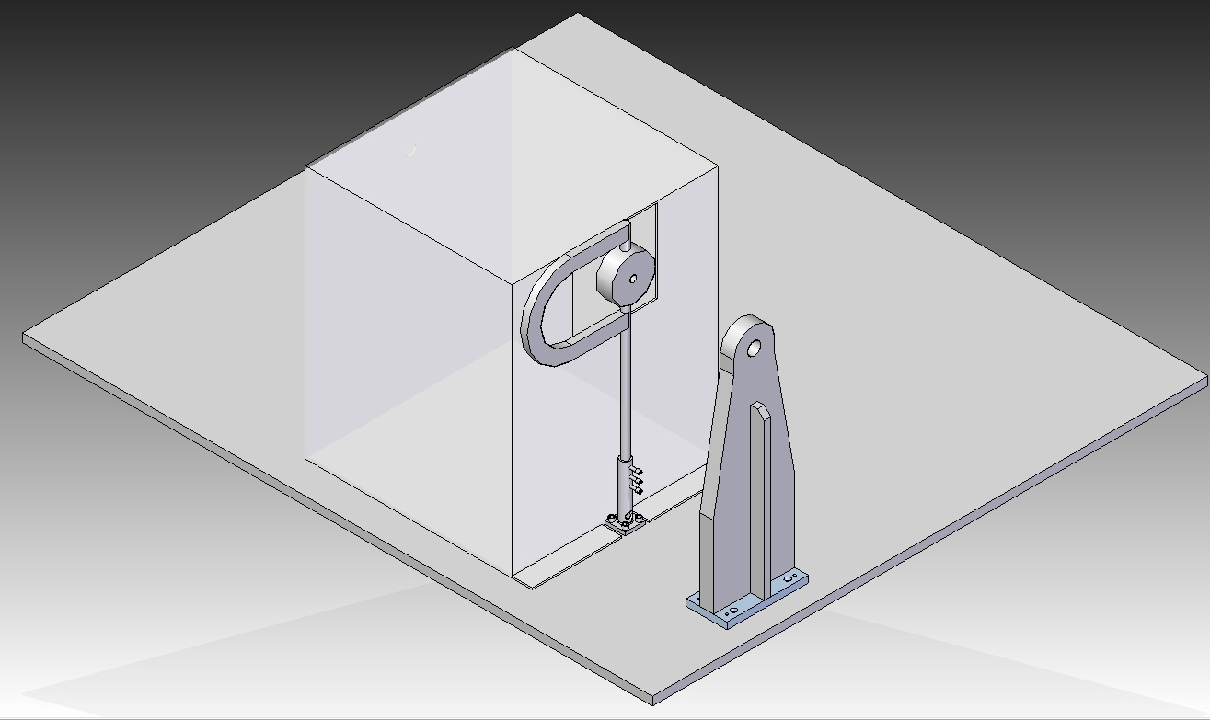

Close Up of the Air Base
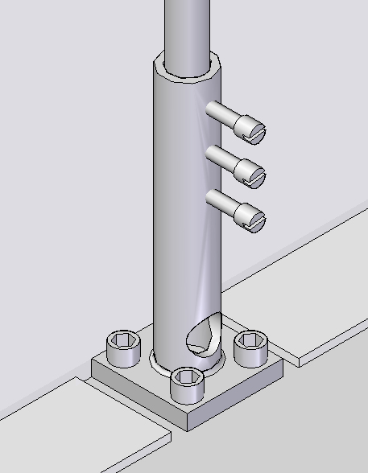

Air Wipe Base (Solid Model)

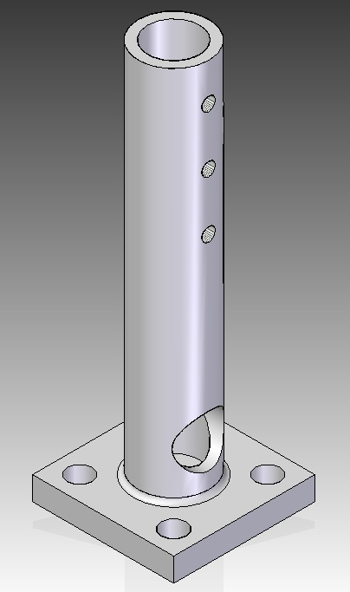

Air Wipe Base (Draft)
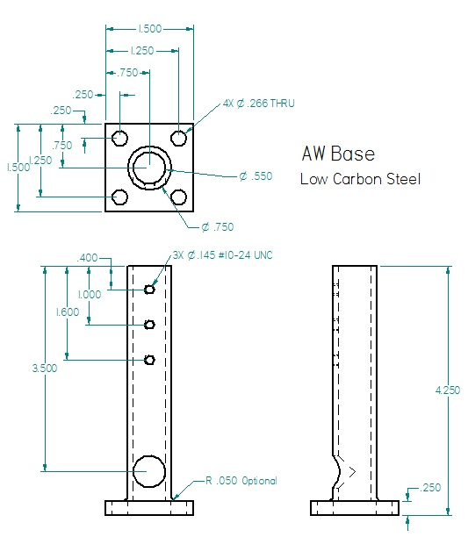

Air Wipe Box (Solid Model)
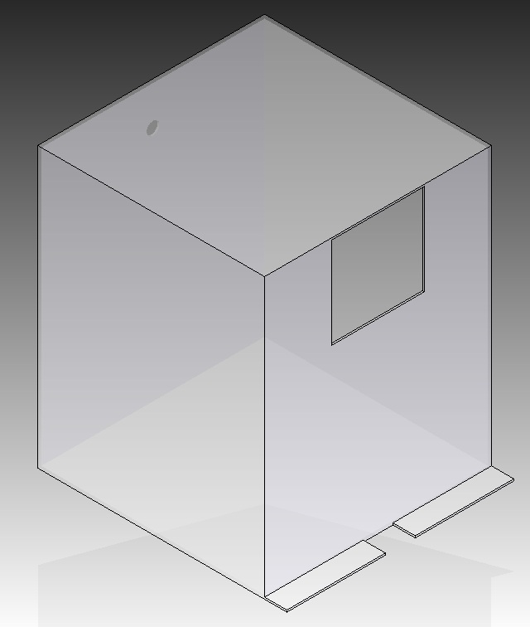

Air Wipe Box (Draft)
